

**Your Name:**

**School:**

**Form:**

**Ruchugi Test Comments and Questions**

The goal of this exercise is to write the comments and questions you have about responses from students in Canada. The second goal of this exercise is to check a box stating if you thought the response was “Expected” or “Unexpected”. Put an X in the brackets next to either “Expected” or “Unexpected” and write any comment or question you have about the response below under “Comment OR Question”.

**EXAMPLE**



**[ ] EXPECTED [ X ] UNEXPECTED**

**COMMENT OR QUESTION**

What animals are people killing? Why do you think this is a problem?

**Question 2: Where you live, what do you believe are the major problems?**

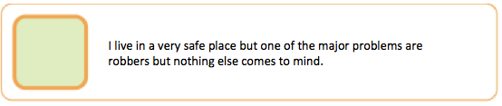

**[ ] EXPECTED [ ] UNEXPECTED**

**COMMENT OR QUESTION**

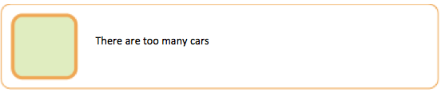

**[ ] EXPECTED [ ] UNEXPECTED**

**COMMENT OR QUESTION**

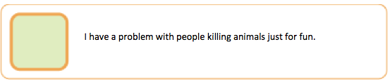

**[ ] EXPECTED [ ] UNEXPECTED**

**COMMENT OR QUESTION**



**[ ] EXPECTED [ ] UNEXPECTED**

**COMMENT OR QUESTION**

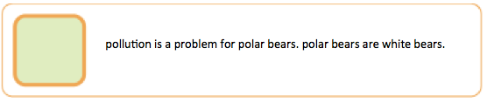

**[ ] EXPECTED [ ] UNEXPECTED**

**COMMENT OR QUESTION**



**[ ] EXPECTED [ ] UNEXPECTED**

**COMMENT OR QUESTION**